

**Lab Report: Electrical Circuits (CSE 209)**

**Expt. No: 04**

**Title: Bias Point Detail Analysis of DC Circuit with Independent Sources Using PSpice**

**Schematics.**

**Submitted by-**

Name: Md.Minhajur Rahman

ID: 2023-3-60-301

Section- 01

Group- 05

**Submitted to-**

Dr. Sarwar Jahan

Associate Professor

Department of Computer Science & Engineering

East West University

**Date of Performance**: 26/11/24

**Date of Submission:** 03/12/24

**Objectives:**

1.To learn fundamentals of PSpice

2.To analyze Bais Point Detail of DC circuit using PSpice schematics.

**Circuit Diagram:**

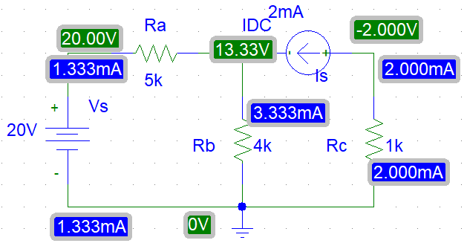

**Figure: 01**

**Solution for the figure 1:**

Applying KVL in mesh 1,

-20+5i1+4(i1-i2) = 0

⸫ 9i1-4i2 = 20 **…..**(i)

From mesh 2,

i2 = -2mA

Sustituting i2 = -2mA in equation (i),

9i1-4*(-2) = 20

Or, 9i1 = 12

⸫ i1 = 1.333mA

For Ra,

i1 = 1.333mA

V1 = 20V

For Rc,

i3 = -2mA

V3 = -2*1V

= -2V

Applying KCL at node A,

i1 = i3+i4

Or, i4 = i1-i3

= (1.333+2)mA

= 3.333mA

For Rb,

i4 = 3.333mA

V2 = 3.333*4

= 13.33V

**Circuit Diagram:**

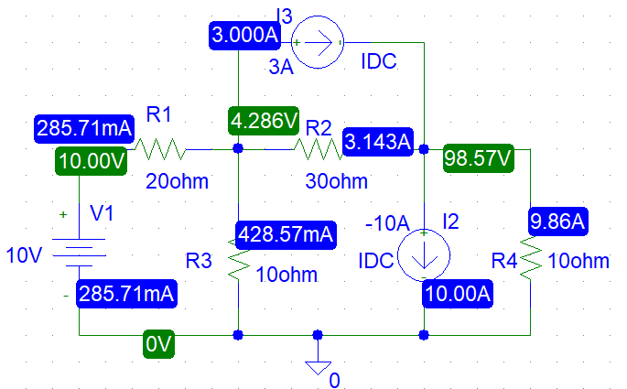

**Figure: 02**

**Post-Lab Report Question:**

**1. Theoretically calculate all the currents and the voltages for the circuit shown in figure 2.**

Solution:

From figure 02,

𝑖2=-10A

𝑖3= 3A

Now,

As VDC is in between node 1 and 0 so,

V1= 10V

Applying KCL and Ohm’s law at node 2 and 3,

*=* + + 3

Or, - V2 - = 30

Or, = 30

⸫ -11V2+2V3 = 150 **…..**(i)

And,

+ 3 = -10 +

Or, – V3 = -100-30

Or, = -130

⸫ V2-4V3 = -390 **…..**(ii)

From (ii),

V2 = -390+4V3 **…..**(iii)

Substituting V2 = -390+4V3 in equation (i);

-11(-390+4V3)+2V3 = 150

Or, 4290-44V3+2V3 = 150

Or, -42V3 = -4140

⸫ V3 = 98.57V

Substituting V3 = 98.57V in equation (iii),

V2 = -390+4*98.57

= 4.286V

By solving equation (i) and (ii) we get,

V2 = 4.286 V

V3 = 98.57V

Now,

𝑖1 = = A = 0.2857A = 258.7mA

𝑖4 ==A = 9.857A

𝑖5 = = A = -3.143A

𝑖6 = = A = 0.4286A =428.6mA

So the values are,

𝑖1 = 258.7mA

𝑖2 = -10A

𝑖3 = 3A

𝑖4 = 9.858A

𝑖5 = -3.143A

𝑖6 = 428.6mA

And,

V1 = 10V

V2 = 4.286V

V3 = 98.57V

**2. Compare the theoretical solution of the circuit shown in the figure with the solutions obtained from PSpice.**

Solution:

Comparing values of voltages,

|  |  |
| --- | --- |
| **PSpice** | **Theoretical** |
| 𝑉1=10 V | 𝑉1=10 V |
| 𝑉2=4.286 V | 𝑉2=4.286 V |
| 𝑉3=98.57 V | 𝑉3=98.57 V |

Comparing values of current,

|  |  |
| --- | --- |
| **PSpice** | **Theoretical** |
| 𝑖1=258.71 mA | 𝑖1=258.7 mA |
| 𝑖2= -10 A | 𝑖2= -10 A |
| 𝑖3= 3 A | 𝑖3= 3 A |
| 𝑖4=9.86 A | 𝑖4=9.86 A |
| 𝑖5= -3.143 A | 𝑖5= -3.143 A |
| 𝑖6=428.57 mA | 𝑖6=428.6 mA |

All the values of currents and voltages we get theoretically; and from the PSpice are equal.

